**Assignment 1**

**DSA0156-Object oriented programming**

**C++ Gaming**

**Parthibhan R**

**192224275**

**1.Odd or Even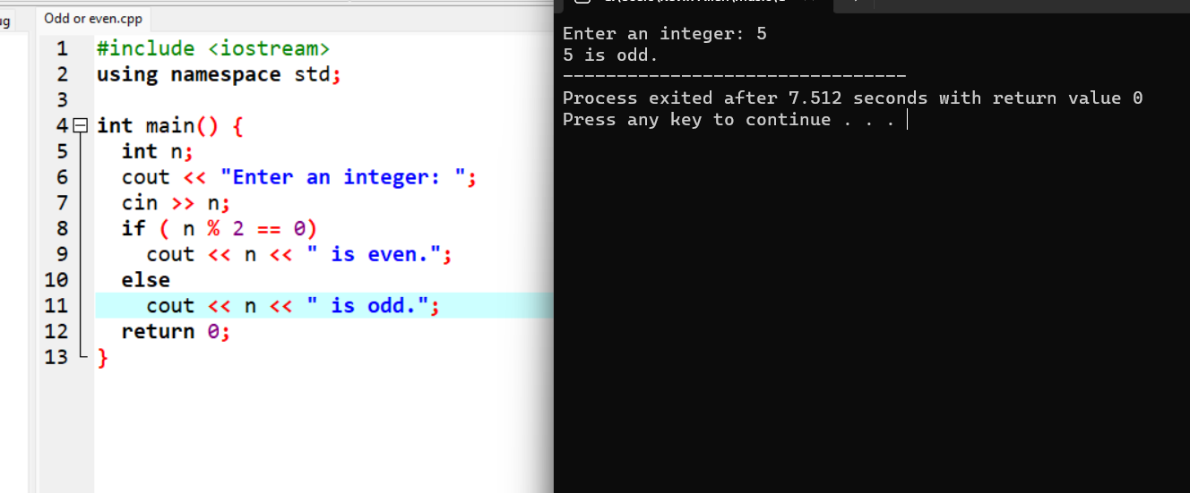2.Vowel or consonant**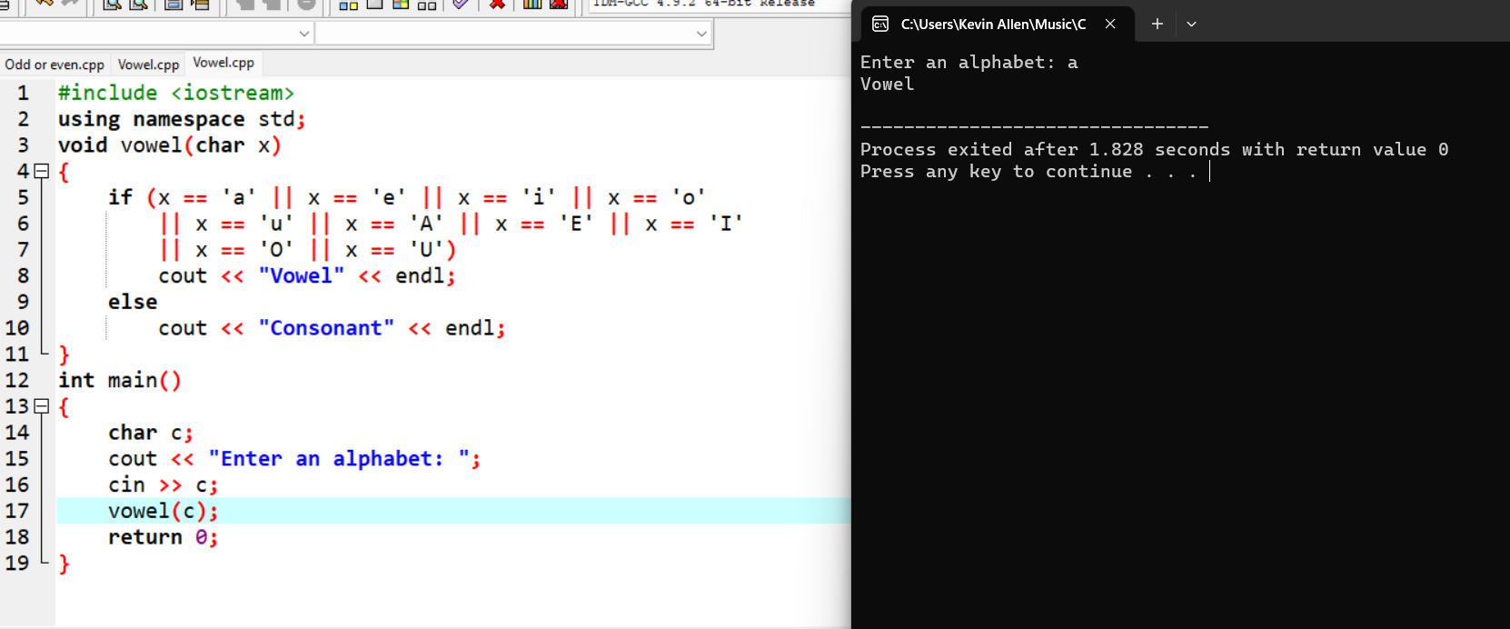

**3.Largest of three numbers**

